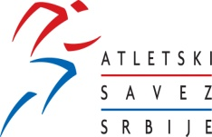

1. SERBIAN OPEN INDOOR MEETING

Serbia-Belgrade, March 01st, 2016

